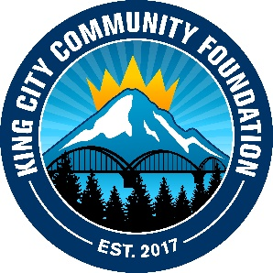
King City Community Foundation

2019 4th of July Walk & Roll Parade and Festival

Vendor Registration Form

The Festival will be held on the 4th of July from 10 am – 2 pm at the King City Community Park
(17470 SW Montague Way, King City, 97224).

Organization Name:___________________________________________________________
Address: ___________________________________________________________________
Phone: ____________________________________________________________________
Website:____________________________________________________________________
Contact Person:______________________________________________________________
Email:______________________________________________________________________
______Check here if you would like us to link/promote you on Facebook / Instagram
Handles:____________________________________________________________________
- Please describe what items you will be selling or displaying with as much detail as possible: __________________________________________________________________
__________________________________________________________________
__________________________________________________________________
__________________________________________________________________

- Please describe any activities your booth will host with as much detail as possible: __________________________________________________________________
__________________________________________________________________
__________________________________________________________________
__________________________________________________________________

Early Bird Vendor Registration Fee: $10.00
Early bird Vendor Registration Deadline: June 15, 2019.
Vendor Registration Fee (After May 30th): $15.00
Final Registration Deadline: June 28, 2019

Once you submit your vendor application form, we will email you a vendor confirmation email, additional festival information and instructions. The registration fee will be due at the time you receive your confirmation email. You can pay through PayPal on our website or via check to KCCF.

Each vendor will be given a 10x10 stall area at the King City Community Park. Vendors must provide their own booths, tables, chairs, covers, etc. Anticipate a sunny, hot day so please consider a tent to shade your booth.

There is NO electricity or potable water available at the park.
Generators will not be allowed except for pre-authorized vendors.

Please return your completed registration form and Waiver of Liability and Hold Harmless Agreement to KCCF4Festival@gmail.com. We are committed to promoting inclusivity and community cohesion. We reserve the right to decline or remove any vendor from the Festival.

For more information contact the Parade & Festival committee:

Email: KCCF4Festival@gmail.com
Phone: 503-862-8072
Address: 15685 SW 116th Ave., PMB #191, King City OR 97224
Follow us on Facebook and Instagram - search KCCFOregon

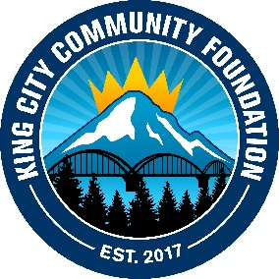
King City Community Foundation

KCCF4Festival@gmail.com · 503-862-8072 · www.KCCFOregon.org

WAIVER OF LIABILITY AND HOLD HARMLESS AGREEMENT

VENDOR NAME:__________________________________________________________________

*****Please note: it is a requirement that all participants in the 2019 4th of July Walk & Roll Parade and Festival sign and return via email the attached waiver by June 15, 2019. Please return to: King City Community Foundation Email: KCCF4Festival@gmail.com or mail to 15685 SW 116th Ave., PMB #191, King City OR 97224. In consideration for receiving permission to participate in the 2019 4th of July Walk & Roll Parade and Festival on July 4, 2019 at the King City Community Park, King City, Oregon (hereinafter “Event”), the Vendor hereby releases, waives, discharges and covenants not to sue the King City Community Foundation, its agents, volunteers, or officers for any and all liability, claims, demands, actions and cause of actions whatsoever arising out of or related to any loss, damage, or injury, including death, that may be sustained by the Vendor, or to any of the property belonging to the Vendor whether caused by the negligence of the Vendor, or otherwise, while participating in such activity, or while in, on or upon the premises where the activity is being conducted.

I am fully aware of the risks involved and hazards connected with the Event and I hereby elect to voluntarily participate in the said activity with full knowledge that said activity may be hazardous to me and my property. I voluntarily assume full responsibility for any risk of loss, property damage or personal injury, including death, that may be sustained by me or any loss or damage to property owned by me, as a result of being engaged in such activity, whether caused by the negligence of Vendor or otherwise.

I further hereby agree to indemnify and hold harmless the King City Community Foundation, its agents, volunteers and officers from any loss, liability, damage or costs, including court costs and attorney fees, that they may incur due to my participation in said activity, whether caused by negligence of Vendor or otherwise.

I understand that the King City Community Foundation will provide or facilitate event insurance for the Event but that I am aware I should review my own insurance portfolio.

Date:_____________________________________________________________

Name of Business:__________________________________________________

Signature:_________________________________________________________
Title:_____________________________________________________________

King City Community Foundation

KCCF4Festival@gmail.com · 503-862-8072 · www.KCCFOregon.org

King City Community Foundation is a registered 501(c)(3) non-profit organization with the mission of supporting arts and recreation in King City, OR.

